Design Hierarchy (Instructor Version)

**Instructor Note**: Red font color or Gray highlights indicate text that appears in the instructor copy only.

1. Objective

Identify the three layers of a hierarchical network and how they are used in network design.

Instructor Note: This activity can be completed individually or in small groups.

1. Scenario

A network administrator is tasked with designing an expanded network for the company.

After speaking with network administrators in other branches of the company, it was decided to use the Cisco three-layer hierarchical network design model to guide the expansion. This model was chosen for its simple influence upon network planning.

The three layers of the expanded network design include:

* Access
* Distribution
* Core

1. Resources

* World Wide Web access
* Presentation software
  1. Use the Internet to research the Cisco three-layer design model for images only.
     1. Find two images that show the three-layer hierarchical design model.
     2. Note the online image’s web address.
  2. Study the two images you have selected from Step 1.
     1. Notice the types of equipment in each layer of the designs you have chosen.
     2. Differentiate why it is assumed the types of equipment shown in the images are located where they are on the design.
     3. Notice any other differences between the chosen images.
        1. Number of devices used within the layers
        2. Redundancy, if any
  3. Create a three-slide presentation to include:
     1. The two chosen designs with hyperlinks as to their Internet site locations.
     2. A statement on each slide as to why the particular image was chosen.
     3. Comparison statements as to how the two images differ, but with an explanation of why they are classified as three-level hierarchical designs.
  4. Present the slides to a classmate, another group, or the class for discussion.

1. Suggested Activity Example (no model numbers are given, as emphasis is on the hierarchical functions of the network devices shown):
2. Slide 1:
3. [Graphic 1](http://www.cisco.com/en/US/i/200001-300000/220001-230000/221001-222000/221701.jpg)

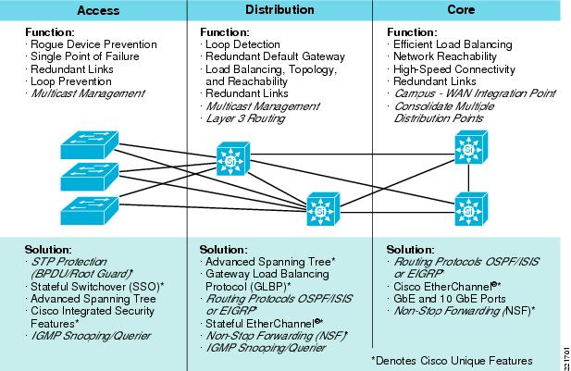

**Student or Group Notes as to why this graphic was chosen:**

* Access layer shows basic switches, Spanning Tree options, redundancy to the Distribution layer, and security considerations.
* Distribution layer shows redundancy, load balancing, and routing protocols linked to the Core layer.
* Core layer shows load balancing, redundancy, routing protocols, and port aggregation.

1. Slide 2:
2. [Graphic 2](http://2.bp.blogspot.com/_9n0GycukLqo/S7HPlv68gyI/AAAAAAAAB6c/ppLqIc0cJ2Q/s1600/network+layers.PNG)
3. 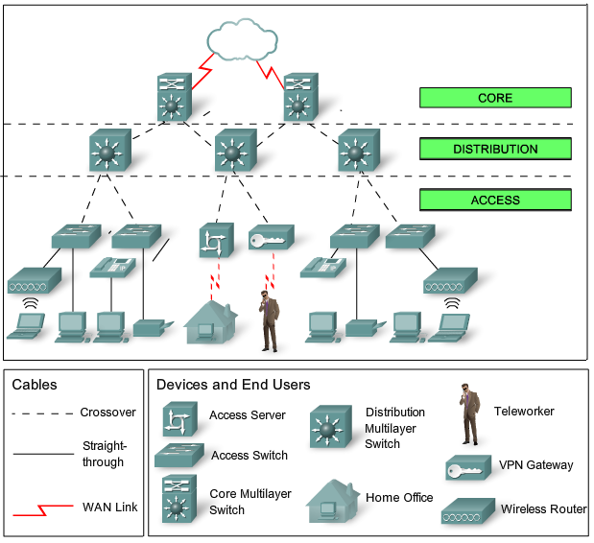

**Student or Group Notes as to why this graphic was chosen:**

* Access layer shows PCs, access switches, VPN gateways, printers, teleworker, home office, and wireless router. Also shown in this layer are redundant links to the distribution layer.
* The distribution layer shows several multilayer switches and link connections to the core layer.
* The core layer shows multilayer switches and connections to the distribution layer and the cloud.

1. Slide 3:

* Basic equipment types are located in the access layer, closest to the user and work with the distribution layer above it. Most of the network devices are located at this level on both images.
* The distribution layer equipment interfaces with both core and access layers in both images. This hierarchical level seems to contain the most sophisticated and multifunctional equipment. Redundancy is clearly apparent to both core and access layers as shown in the first model. It would seem that high-powered multifunction switches would be located at this level of the two graphics. The number of network devices shown in both graphics at this level is smaller than the access layer, but larger than the core layer.
* As shown in the two previous graphics, the core layer has the most sophisticated equipment. There are fewer network devices at this layer, which seems to indicate that the devices are highly functioning and fast traffic processors.

1. Identify elements of the model that map to IT-related content:

* Cisco hierarchical design-model levels
  1. Access
  2. Distribution
  3. Core
* Cisco hierarchical design model functions
* Types of equipment located in the layers of the hierarchy
* Amount of equipment located in the layers of the hierarchy